# Title: On all pages. Section "Iнформація" has wrong placement

**Priority:** High

**Severity:** S4 Minor

**Environment:**Browser Mozilla Firefox 118.0.1 (64-bit)

Browser Chromium 117.0.5938.132

**Steps to reproduce**

1. Open the Main page: <https://oxford-med.com.ua/ua/>

2. Scroll down to the gray “footer” with a list of the clinic’s departments

**Actual result**

We see that a section “Iнформація” has wrong placement (or this section is empty).

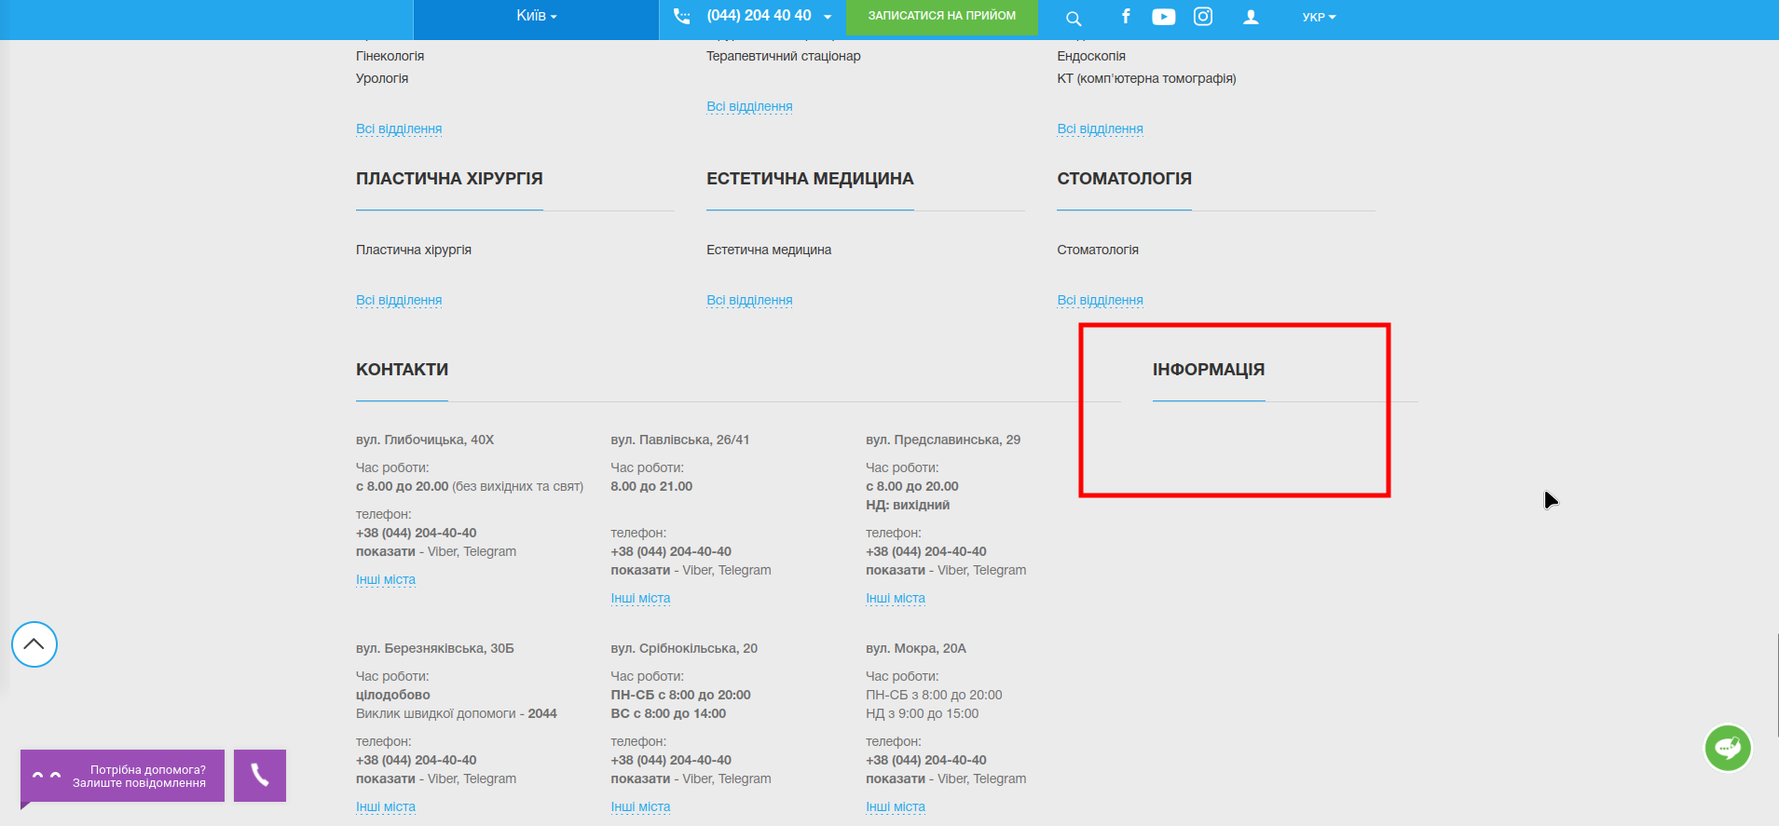

**Expected result**

According to UI-UX, all sections, blocks, and texts must have logic placement. So, “Iнформація” section must be moved to another place or this empty section must be filled with a content.

*Screenshot from* ***Jira****:*

